📘 Project Report: Deploying a Static Website on AWS

**🔹 AIM**

To deploy a responsive, modern static website (HTML, CSS, JavaScript) using AWS cloud services such as S3, CloudFront, ACM, and Route 53, with HTTPS support and custom domain integration.

**🔹 TECHNICAL SKILLS USED**

* **HTML/CSS/JavaScript** – Designing the static frontend
* **AWS S3** – Hosting website files
* **JSON** – Policy configuration

**🔹 STEPS FOLLOWED**

1. **Create Website Files**
   * **Created a folder with index.html, style.css, and any required images or JavaScript files.**
2. **Login to AWS Console**
   * **Opened** [**https://aws.amazon.com/console**](https://aws.amazon.com/console) **and signed in.**
3. **Create an S3 Bucket**
   * **Navigated to Amazon S3.**
   * **Clicked Create bucket.**
   * **Gave the bucket a unique name, my-static-website-sanchi .**
   * **Selected the AWS region.**
   * **Unchecked "Block all public access" (to allow public viewing).**
   * **Clicked Create bucket.**

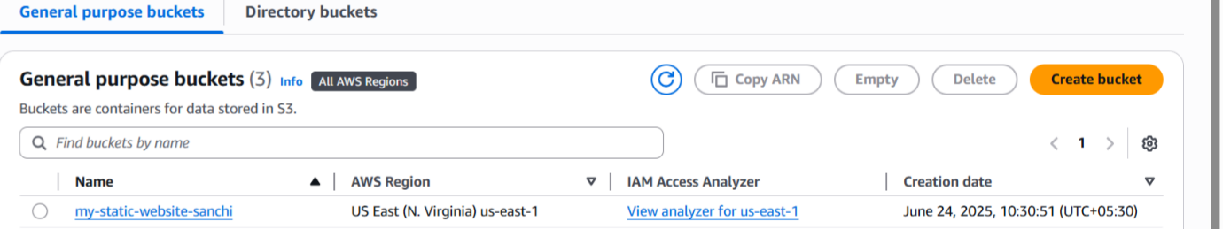

1. **Upload Website Files to the Bucket**
   * **Clicked on the newly created bucket.**
   * **Chose Upload, added all website files, and uploaded them.**

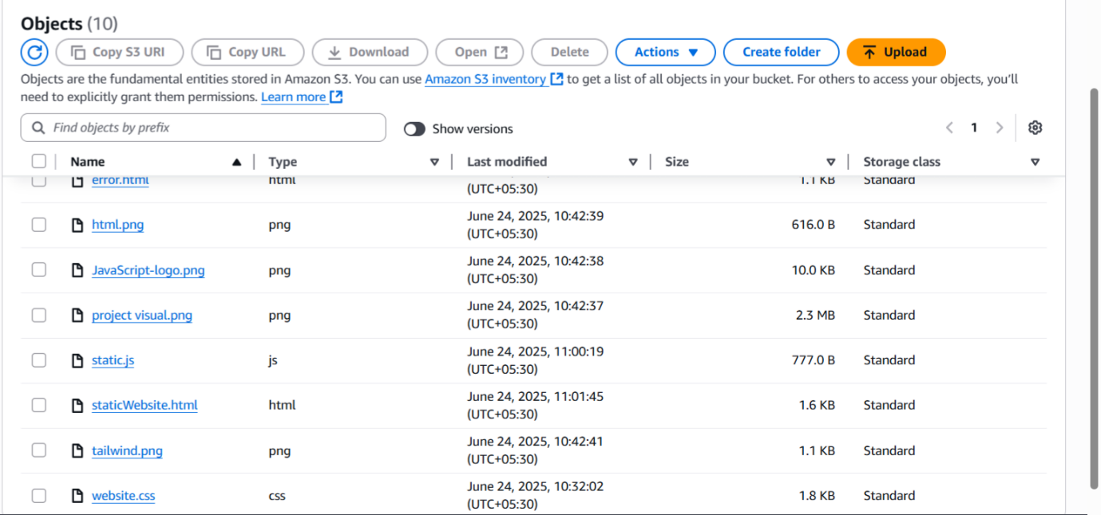

1. **Enable Static Website Hosting**
   * **In the bucket, navigated to the Properties tab.**
   * **Scrolled to Static website hosting.**
   * **Enabled it.**
   * **Set Index document as staticWebsite.html.**
   * **Set Error document as error.html.**
   * **Saved changes.**
2. **Make Files Public**
   * **Selected the uploaded index.html (and other files).**
   * **Clicked Actions → Make public (or used the Permissions tab).**
   * **How to use permission tab?**
     1. **Go to permission tab.**
     2. **Go to bucket policy and click on edit.**
     3. **Then copy this code:**

**{**

**"Version": "2012-10-17",**

**"Statement": [**

**{**

**"Sid": "AllowPublicReadAccess",**

**"Effect": "Allow",**

**"Principal": "*",**

**"Action": "s3:GetObject",**

**"Resource": "arn:aws:s3:::my-static-website-sanchi/*"**

**}**

**]**

**}**

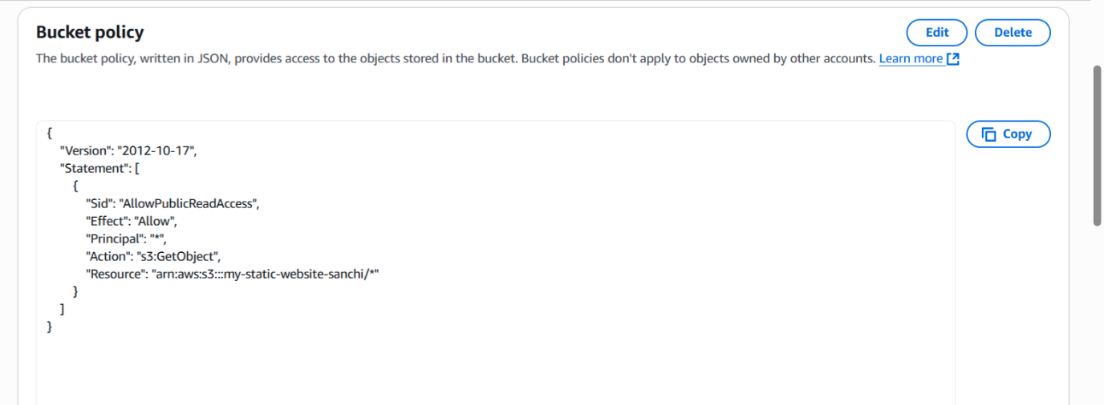

* + **Confirmed the public access.**

1. **Get the Public URL**
   * **Clicked on the staticWebsite.html file from the object menu.**

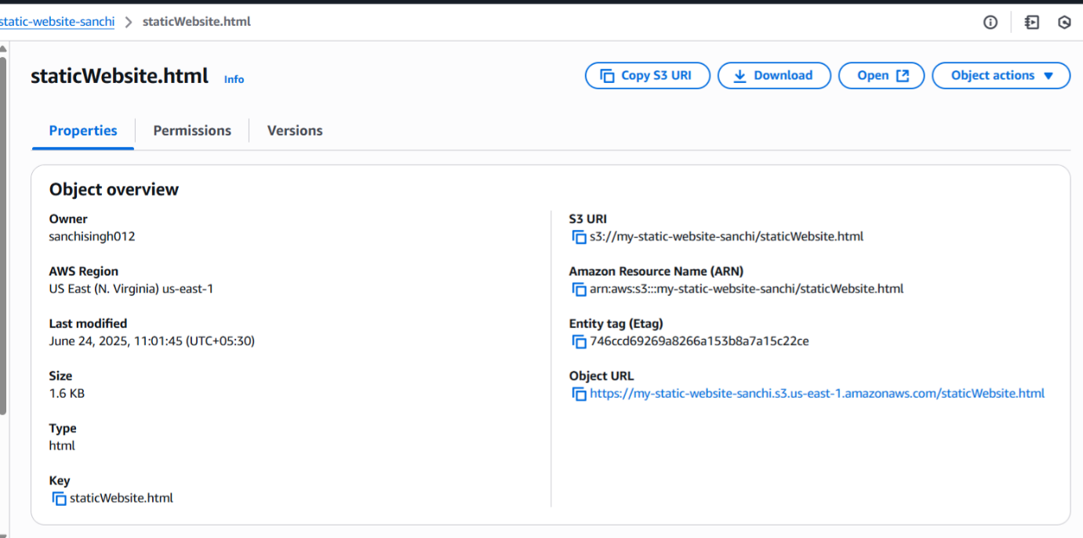

* + **Copied the Object URL shown (something like:)**

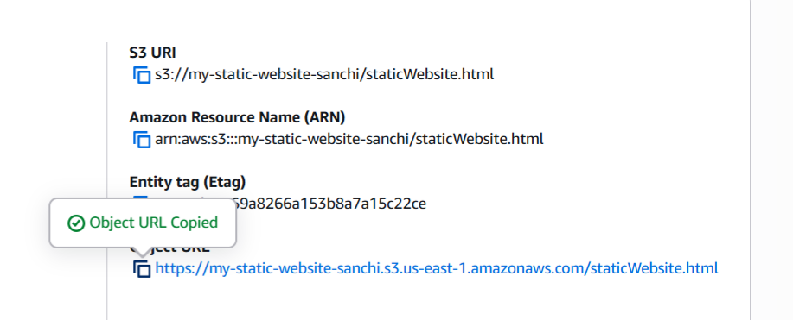

* + **Opened the link in a browser to view the website live.**

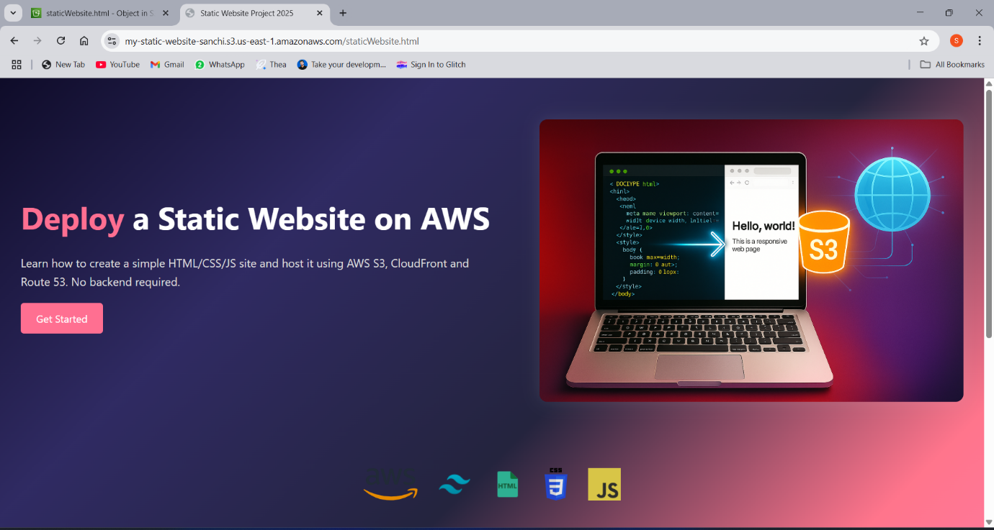

**🔹 CHALLENGES DURING FOLLOWING STEPS**

* **CORS Issues**: Incorrect MIME types or missing headers on JS files

**🔹 TROUBLESHOOTING STEPS**

* Used browser DevTools (F12) to check network issues and JS errors
* Reuploaded files after fixing folder structure and paths

**🔹 FINAL STATEMENT**

This project successfully demonstrates end-to-end static website deployment using AWS. By combining storage (S3), global content delivery (CloudFront), secure access (ACM), and domain control (Route 53), the result is a highly available, scalable, and secure website ready for real-world use.